

The Graduate School of Business Administration

2 St David’s Place, Parktown, Johannesburg, 2193, South Africa
PO Box 98, WITS, 2050
Telephone: +27 11 717 3600, Facsimile: + 27 11 643 2336
Website www.wbs.ac.za

April 20, 2021
The CLM Faculty Office

REQUEST FOR EXTENSION TO SUBMIT COMPLETED PHD WORK: MR JOHN KARUITHA

Like most of my Full-time PhD students, who though were physically present here in Johannesburg during all of 2020, Mr John Karuitha had his work –more so the data analysis from WBS computer lab and Wits Libraries – interrupted for over a period of six months due to the Covid-19 pandemic caused national lock-down orders.

And this delay is in addition to Mr Karuitha’s heavy computing requirements to run the data analysis which could best be done in the University computer laboratories. In addition, Mr. Karuitha experienced delays processing his study visa due to the lockdown in South Africa and had to travel back to his home country Kenya as his visa was expiring. In Kenya, the national lockdown has significanlty delayed his visa processing so that he can travel back to South Africa to clear his research. He is set to travel backin May, 2021.

In my place as his supervisor, who is intimately aware of the significance of this disruption and especially in the midst of the volume of work required to piece together and submit a PhD thesis, I am strongly in support of his request for extension of about a quarter of the year to enable him submit a completed work. It is a high quality work that Wits Business School and the University at large will be proud of.

Thank you in advance for seeing very cogent reasons to grant Mr Karuitha this requested extension.

Sincerely yours,

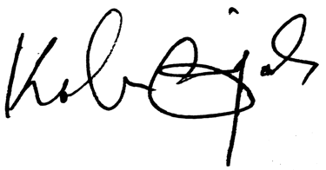

Kalu Ojah, PhD
Professor of Finance
Kalu.Ojah@wits.ac.za

